Massachusetts Chapter of the

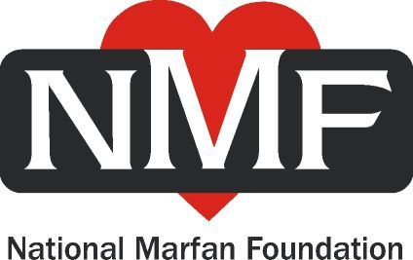

Physician Awareness Committee

We are pleased to announce that Dr. Ronald Lacro, Dr. Michael Singh, Dr. Michael Murray and Martha C. King, RN, are working with the Massachusetts Chapter of the National Marfan Foundation to raise awareness about Marfan syndrome and elevate the level of patient care for affected people in our local area hospitals.

Dr. Lacro is the Director of the Marfan Syndrome Program at Children’s Hospital Boston; Dr. Singh is the Co-Director of the Marfan Syndrome Program at Children’s Hospital Boston and the Co-Director of the BWH Comprehensive Marfan Clinic at Brigham and Women’s Hospital; Dr. Murray is the Co-Director of the BWH Comprehensive Marfan Clinic; and Ms. King is the Clinical Coordinator for the Marfan Syndrome Clinic at Children’s Hospital Boston.

Through this collaboration, we plan to provide area health professionals with the most current information on Marfan syndrome through customized presentations for various specialists. Presentations focus on early detection of Marfan syndrome and effective management and monitoring of the condition. Because these patients are at increased risk for aortic dissection, emphasis is also placed on preventing a potentially fatal episode, and how to evaluate and treat one if it does occur.

Drs. Lacro, Singh and Murray, along with Ms. King, are available to present to a range of audiences—from division or departmental conferences to Grand Rounds. We can offer comprehensive or multidisciplinary talks of general interest to primary care providers, including pediatricians, and tailored presentations for disciplines including cardiology, cardiac surgery, emergency medicine, orthopedics, ophthalmology, genetics or obstetrics. We can also arrange meetings tailored to attending physicians, trainees, medical students, nurses and other health care professionals.

Supplementing the presentation, we can offer a two-hour AMA accredited video, Emergency Diagnosis and Treatment of Aortic Dissection, produced by the National Marfan Foundation. Marfan patients are also available to offer the patient perspective and to answer questions based on their experience living with the disorder.

We hope you are interested in taking advantage of this opportunity to better treat Marfan patients. Please let us know whom we may contact at your institution to arrange a presentation. We are happy to work with your Continuing Education Department or other staff members to accommodate your specific needs.

For more information or to arrange a presentation, please contact Jonathan Rodis or Stephen Griffin, co-chairs of the Physician Awareness Committee, or Martha C. King, RN. Their contact information is below.

Thank you for your consideration.

Most sincerely,

The Massachusetts Chapter of the NMF
Physician Awareness Committee

Jonathan Rodis jrmarfan58@aol.com 617-846-4975, Stephen Griffin sdg617@yahoo.com
Martha C. King, RN martha.king@cardio.chboston.org 617-355-8794

